CURRICULUM VITAE

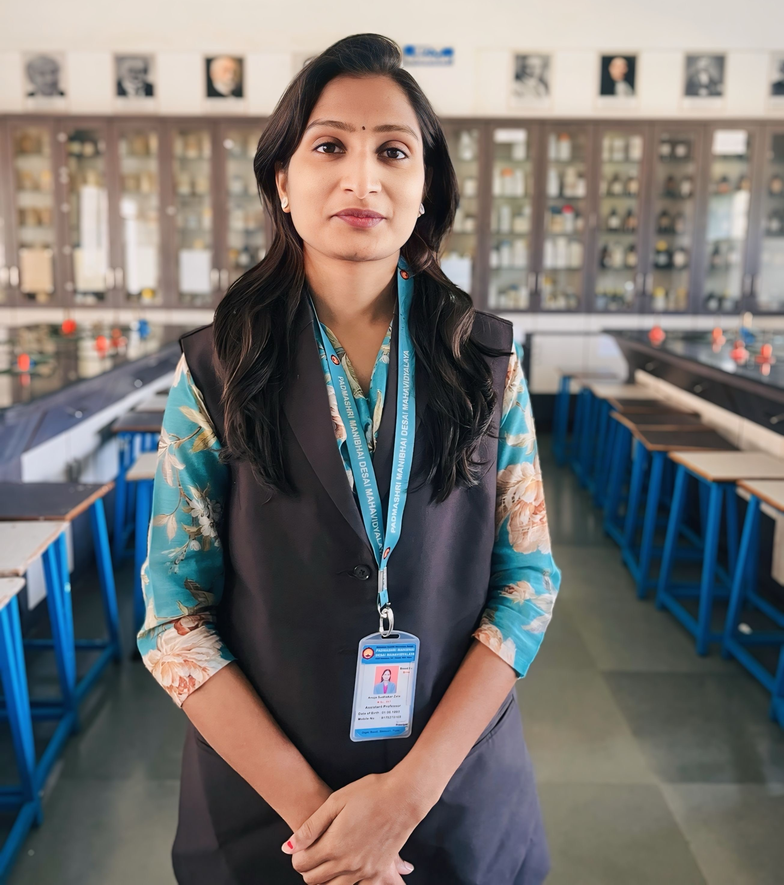
Name : Zate Anuja Sudhakar

Birth Date : 01 June 1992

College : Pad. Manibhai Desai Mahavidyalay,
At. Urulikanchan, Tal: Haveli, Dist: Pune
412202

Correspondence Address : Dighi Road, Bhosari
Tal: Haveli, Dist: Pune 411039

Mobile : +91 9175275168

Email ID : anujazate122@gmail.com

- Academic Achievements:

Examinations | Name of the Board / University | Year of Passing | Percentage of marks obtained | Grade | Subject
S. S. C | Maharashtra Board | 2009 | 84.15% | First class with Distnction | -
H. S. C. | Maharashtra Board | 2011 | 61.33% | A | PCMB
B.Sc. | University of Pune | 2014 | 71.52% | A | Microbiology
M.Sc. | University of Pune | 2016 | 69.80% | O | Microbiology
SET | University of Pune | 2019 | Pass | - | Life Science

- Research Paper Publication:

Sr. No. | Title with page Nos. | Journal / Pros | ISSN / ISBN No.
1 | An attempt to reduce the fermentation time for making idlis faster | International Journal of Recent Scientific Research | 0976-3031
2. | Algae -based Biofuels:A Sustainable Solution for Future Energy Needs | International Journal of Multifaceted and Multilingual Studies | 978-81-984753-5-0
3 | Isolation of Fungi producing pigments and Characterization of Pigments | International Journal of Multifaceted and Multilingual Studies | 2350-0476
4 | A case study: Soil and its role in sustainable ecosystem | International Journal of Multifaceted and Multilingual Studies | 2350-0476
5 | Study on Property of Agaricus bisporus (Button Mushroom) | International Journal of Multifaceted and Multilingual Studies | 978-81-984753-5-0
6 | Development and Formulation of a Natural Room Freshner from Azadirachta indica(Neem) | International Journal of Multifaceted and Multilingual Studies | 978-81-984753-5-0

- Books Published:

Sr. No. | Title of the Book | Type of Book | Publisher & ISNB No. | Year
1 | Food and Dairy Microbiology | Ebook and Paperback | 978-93-5473-221-8 | 2021
2 | Fermentation Technology I and Agricultural Microbiology- | Practical Handbook | IJMS and 978-93-93337-17-7 | 2022

- Contributory / edited Book : Chapters Published / Editor / member of editorial board

Sr. No. | Name of the book and Topic / Chapter | Type of Book Text / Ref. / Distance
1 | Marine Micrbiollogy- | Objective book

- Award
Sr. No. | Details (Maintain Year, Value etc.) | Name and Status | Agency
1 | Lila Poonawalla Foundation Scholarship 2014 | - | -
- Teaching Experience-
Sr.No | Name of the Institution | Period | Position
1. | Padmashri Manibhai Desai Mahavidyalaya | 2017 till date | Full time
- Administrative Experience – At college level
Sr.No | Name of Committee | Position
1. | IQAC Committee | Member
2. | Placement Cell | Member
3. | Exam Committee | Member
4. | Women Cell | Member
5. | Alumini Committee | Member

8 )Activities:
1.One -day seminar on Ancient Groves and Modern Science: Bridging Wisdom in Conservation
2.One -day State level seminar on “Trends in Life Sciences 2020” at Annasaheb Magar Mahavidyalay
3.One- day national webinar on “Scientific Writing in Life Science “organized by International Journal of Microbial Science and Microbiologist’s Society, India.
4.International Webinar held on 19th and 20th July 2020 “Data Presentation in Research Article and its Publication”.
5.One -Day ‘FYBSc Syllabus Restructuring as per NEP 2020’Workshop Organized by SPPU and Sinhagad College, Pune
9) Various activities have done –
1. Coordinator of Avishkar Research Competition at College Level
2. Working as Head, of NAAC Criteria VII at college level
3. Arranged Industrial visit for SY and TY B.Sc students.
4. Arranged Guest lecturers under departmental activities.
5. Worked as External Examiner for Practical EXAMS
6. Worked as Senior Supervisor for university examination at college level
7. Arranged Poster and model competition at college level
8. Coordinator of Various Certificate Courses under Department level

Signature

(Zate.A.S. )

